Without creating file of list of files copying data using for each activity

1. Here if we want to copy the data from the particular files having different names
2. Create

For I in lst:

Copy

1. For that create list variable before to store the filenames
2. Create variable select type array

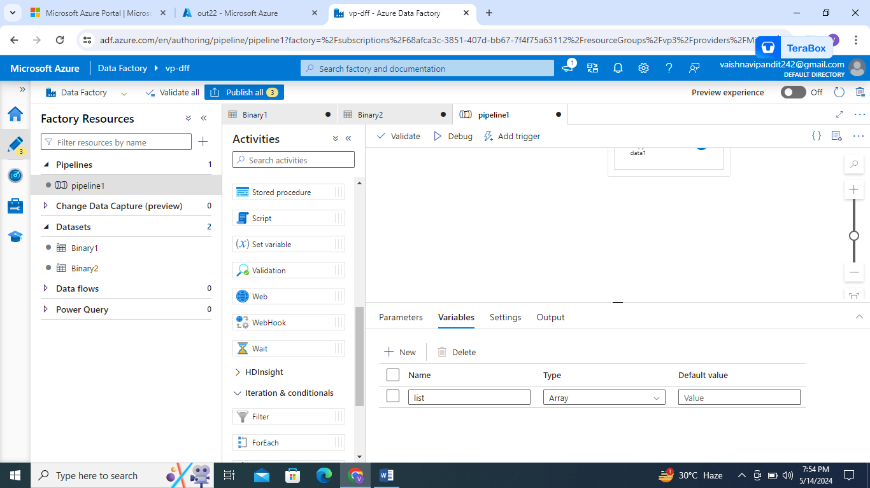

1. Create set variable method for the variable
2. Add value as list ex:[“ff.txt”,”tt.txt”]
3. 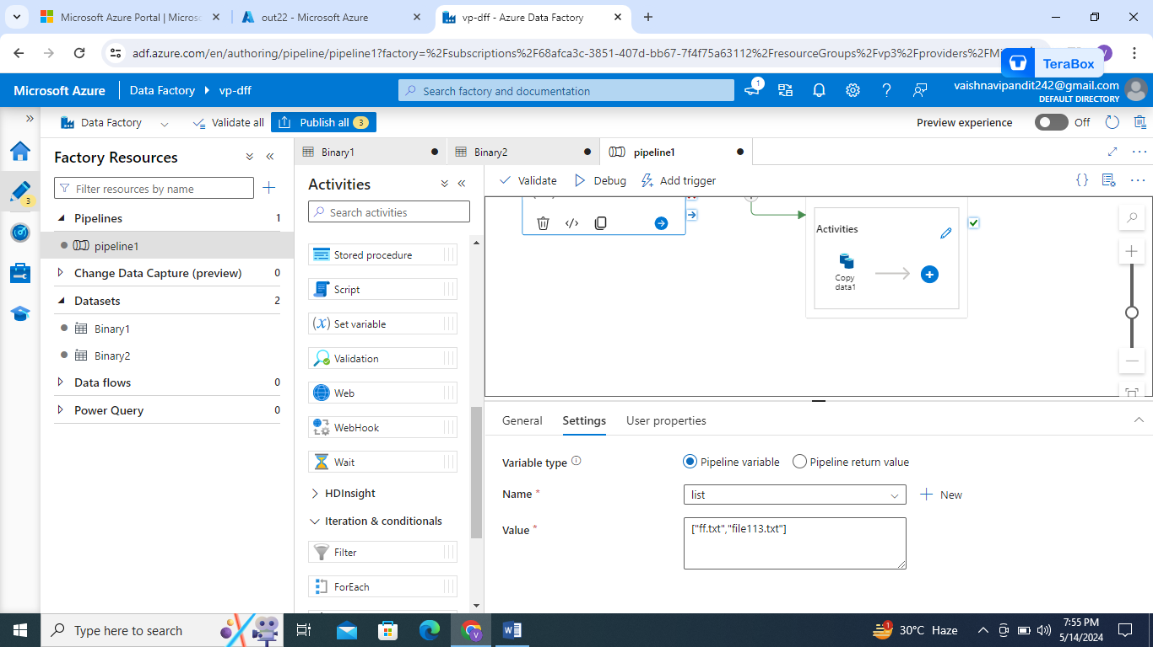
4. Now go to the iterations and conditions in pipeline and drag and drop for each activity
5. Connect set variable to the for each activity

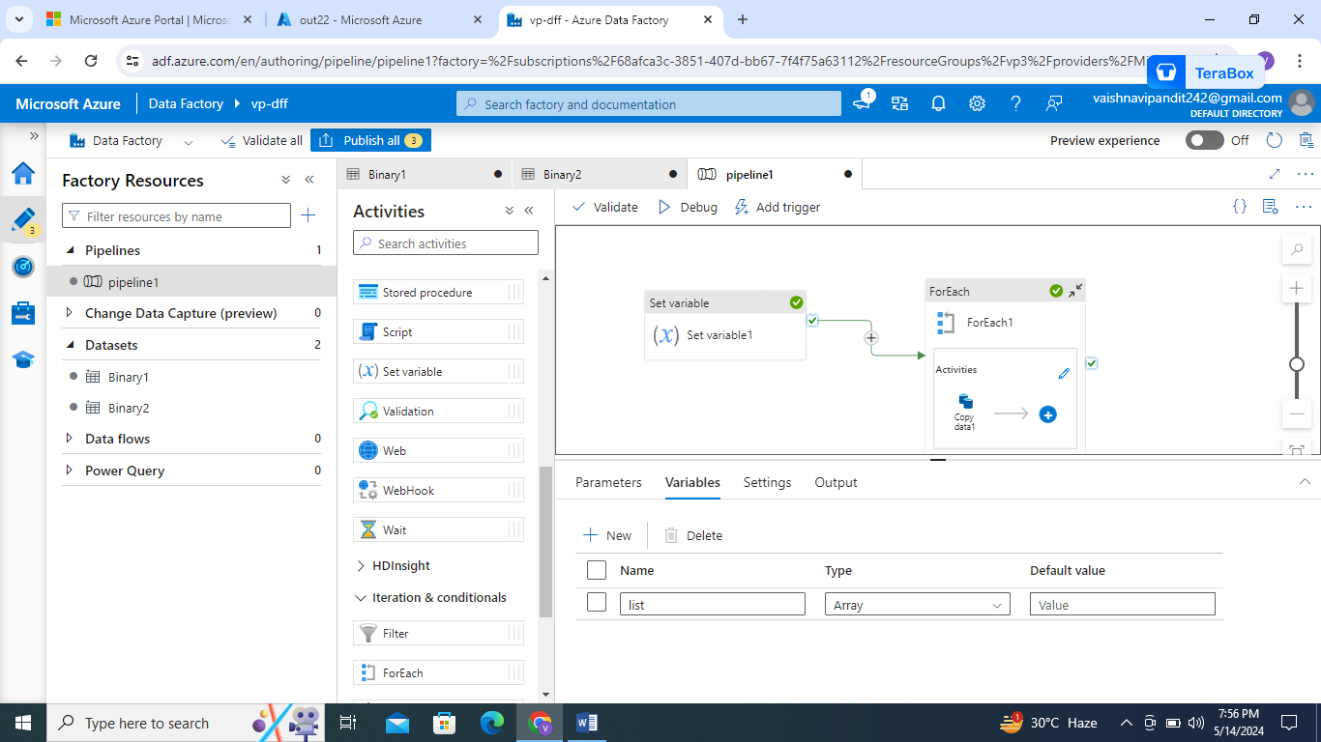

1. In for each activity go to setting and add value as variable list
2. 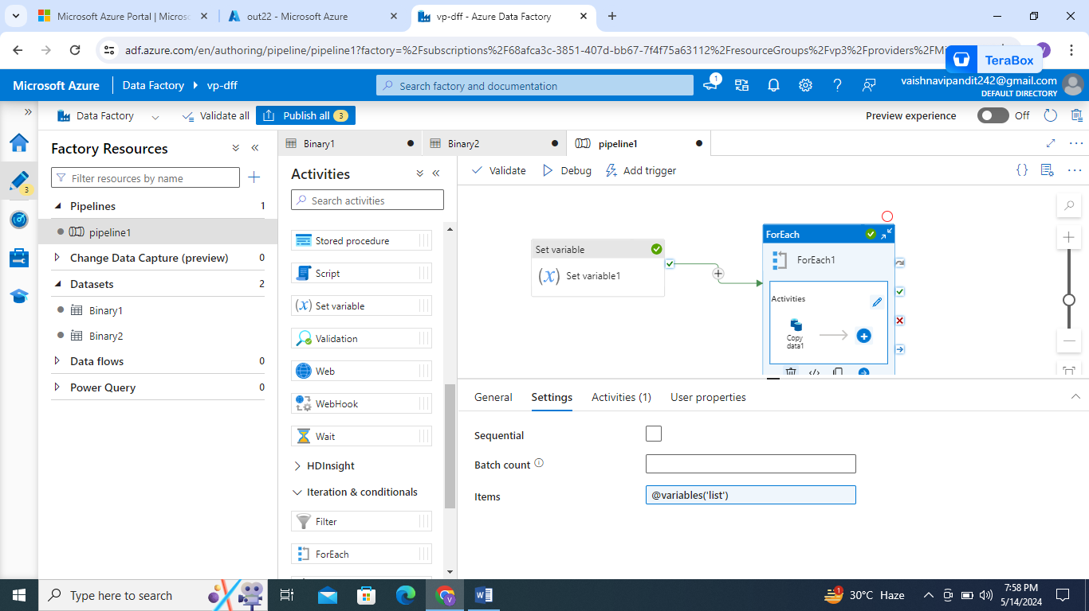
3. Then go to activity and drag and drop copy data
4. 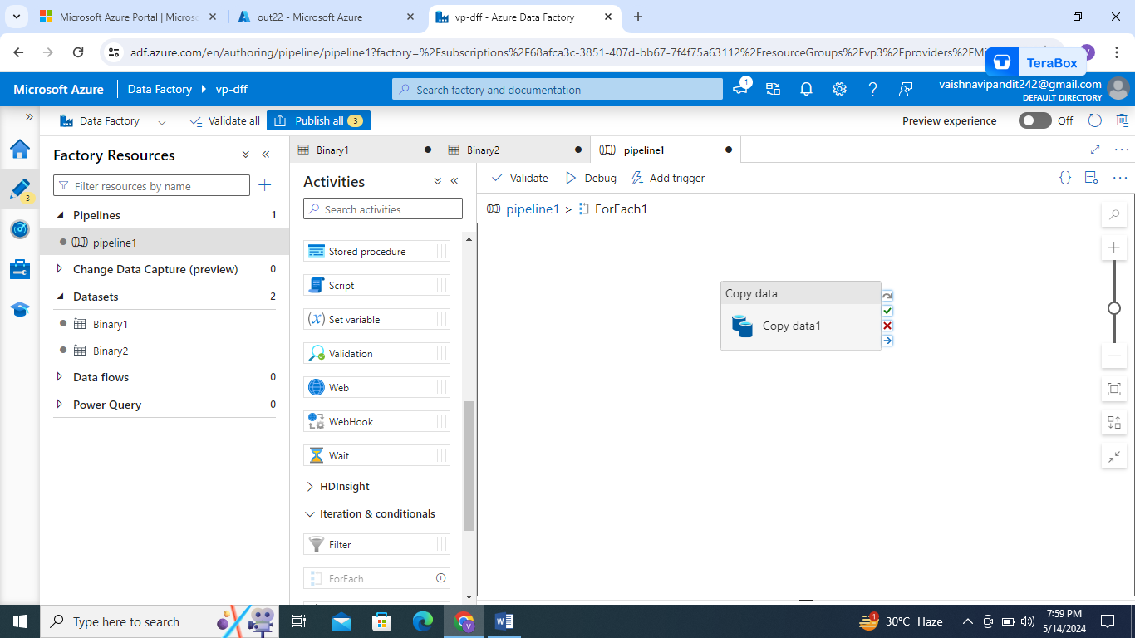
5. In copy data source add dataset and in value for file parameter go to add dynamic contents and select foreach

So it will set @item()

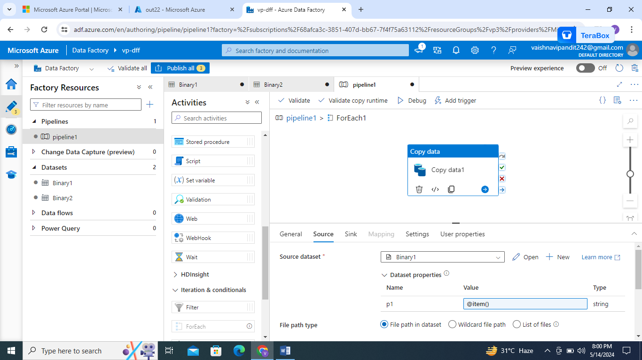

1. Then go to the sink add dataset and again go to pipeline 1 and debug